APES Review Worksheet #1
- List the 4 most populated countries in the world.
Population
Time
1) 3)
2) 4)
- Use the axes to the right for the following:
  - Draw and label a line that represents linear growth.
  - Draw and label a line that represents exponential growth.
- Define the term ecological footprint

- Write an equation for the rule of 70:
- Perform the following calculations: (Show all of your work in a logical progression to the final answer.)
  - A city has a population of 50,000 in 2012. If the population of the city grows at an annual rate of 2%, the year in which the population will reach 100,000 is _____________ and the year it will reach 200,000 is _____________.
Show work:

  - A country’s population was 12 million in 1992 and in 2012 it is 24 million. If the population grew at a constant rate, that percent rate of growth was _____________.
Show work:

- Complete the following table by writing “high” or “low” in each box below.
Characteristic | More Developed Counties | Less Developed Countries
per capita GDP
degree of industrialization
infant mortality rate
relative fossil fuel use
ecological footprint
greenhouse gas emissions
risk from heart disease
risk from infectious diseases
- Provide three examples of renewable resources and three examples of nonrenewable resources.
renewable: 1) nonrenewable: 1)
2) 2)
3) 3)
- Define the following:
  - total fertility rate

  - replacement level fertility

  - infant mortality rate

  - crude birth rate

  - crude death rate

- Describe the circumstances that will result in a Tragedy of the Commons.

- Describe an example of a Tragedy of the Commons.

- Use the axes to the right for the following:
Population
Time
  - Draw a line showing a population that exemplifies logistic growth. (s-curve)
  - Draw label the carrying capacity.
- Describe an example of a positive feedback loop.

- Perform the following calculation. Show all of your work. In a particular year a population has the following characteristics: the crude birth rate is 45, the crude death rate is 20, the immigration rate is 1%, and the emigration rate is 0.5%. The percent rate of growth for that year is __________.
Show work:

- Use the axes below to draw and label lines representing the birth rate, death rate and total population size during the idealized demographic transition of a country. Include, written directly onto the graph, an explanation for each change in the birth rate, death rate and total population size.

- On the axes below, draw and completely label four age-structure diagrams that represent slow growth, rapid growth, negative growth, and zero population growth (include labels on the x- and y-axes)
Rate/
Population
size
Time
- Provide three examples organic compounds and three examples of inorganic compounds.
organic: 1) inorganic: 1)
2) 2)
3) 3)
- Arrange the following types of electromagnetic radiation in order from lowest to highest energy: ultraviolet, microwave, infrared, gamma, radio, x-ray, visible.

- Arrange the following types of visible light in order from shortest to longest wavelength: green, orange, red, yellow, blue, violet.
Survivorship
Time
- Draw and label three survivorship curves using the axes on the right.
- Describe an example of a negative feedback loop.

APES Review Worksheet #2
- List three consequences of global warming.
1)
2)
3)
- List three things you could do to decrease your contribution to global warming.
1)
2)
3)
- List four greenhouse gases.
Altitude
(km)
Temperature (°C)
1) 3)
2) 4)
- The molecular formula of ozone is ________.
- Use the axes to the right for the following:
  - Draw a line representing the Earth’s atmosphere.
  - Label each layer of the Earth’s atmosphere and identify where the greenhouse effect occurs and the ozone layer is situated.
- The chemicals that deplete the ozone layer are __________.
- In the box below, write out a series of chemical equations that illustrate the destruction of the ozone in the ozone layer.
- Provide examples of three biotic components of an ecosystem.
1) 2) 3)
- Provide examples of three abiotic components of an ecosystem.
1) 2) 3)
- Complete the following table:
Trait | Carbon | Nitrogen | Phosphorus | Water
importance to life
largest reservoir
method of transport
cycle length (long/short)
- Write the balanced chemical equation for photosynthesis in the box on the right.
Photosynthesis:
- The approximate age of the Earth is _______________ years.
- Write the balanced chemical equation for cellular respiration in the box on the right.
Cellular Respiration:
- Match the following:
  - generalist species Zebra mussel
  - specialist species Galapagos tortoise
  - invasive species American Alligator
  - keystone species Tiger salamander
  - indicator species Norway rat
  - endemic Species Giant Panda
- Define the term biodiversity.

- Humans have engaged in agriculture for approximately ____________ years.
- Define biome

- A man-made product is also known as __________________.
- Sketch and/or label the following on the map of the world below:
  - the equator
  - the tropic of Cancer and the tropic of Capricorn
  - the Mid-Atlantic Ridge
  - the location of suppressed upwelling characteristic of the occurrence of El Niño
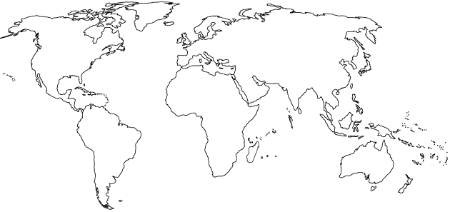
  - the location of Diamond Bar, China, India, Ethiopia, Brazil, and Bangladesh
- Complete the following table:
Type of Biome | Typical Location | Typical Climate | Adaptations for survival
Tropical Rain Forest
Temperate Deciduous Forest
Taiga (Boreal) Forest
Tropical Grasslands (Savanna)
Temperate Grassland (Prairie)
Tundra (cold grassland)
Desert
- Describe the circumstances that will result in cultural eutrophication.

- Explain how increasing the concentration of carbon dioxide in the atmosphere leads to ocean acidification.

APES Review Worksheet #3
- Perform the following calculations: (Show all of your work.)
  - A rectangular area of forest that measures 10 thousand meters by 300 thousand meters has an area of ___________ square kilometers and ___________ hectares.
Show work:

  - A 60-Watt light bulb that is used for an average of 4 hours each day uses ___________ kilowatt-hours of electricity per year.
Show work:

- List two characteristics of an r-selected species.
1) 2)
- List two characteristics of a K-selected species.
1) 2)
- A Pacific Yew is a ____________ and it is endangered because of the following:

- A Piping Plover is a ____________ and it is endangered because of the following:

- An Orangutan is a ____________ and it is endangered because of the following:

- A Dodo was a ____________ and it is extinct because of the following:

- Complete the following table:
Ecosystem Component | Ecosystem Services
honey bee
water cycle
forest
bat
bacteria
coral reef
wetland
- A company is importing rare tropical hardwood to manufacture furniture, list three laws, regulations, treaties, or acts that the company may have violated.
1)
2)
3)
- Whaling is justified in the name of ________________ research, by the countries of ___________ and ___________.
- Two islands, different distances from the mainland have different rates of extinction, this is explained by the theory of island ________________________.
- ________________________ is a technique typically used to harvest scallops, crabs, and shrimp from the sea floor.
- A fishing practice that is commonly used to catch large solitary species of fish and was featured in The Perfect Storm is ________________________.
- List four innovations that led to the Green revolution.
1)
2)
3)
4)
- To live a healthy, active life most adults need to consume approximately ___________ calories of food each day.
- Arrange the following foods in order of highest to lowest in terms of global production: corn (maize), rice, wheat
1) 2) 3)
- Match the following:
  - anemia iron deficiency
  - goiter vitamin A deficiency
  - scurvy vitamin D deficiency
  - rickets iodine deficiency
  - blindness vitamin C deficiency
- Use the axes below to draw and label an illustration of the pesticide treadmill.
Pest Population
size
Time
- Arrange the following particles in order of smallest to largest: clay, sand, silt
1) 2) 3)
- Explain how the biomagnification of DDT led to the demise of the Bald Eagle population in the US.

- _____% of the Earth is covered with water. Of all the water on Earth _____% of it is saltwater, _____% is frozen, and _____% is available and relatively accessible.
- List three things you could do to conserve water.
1)
2)
3)
- Perform the following calculations: (Show all of your work.)
  - A family of 5 replaces a 6-gallon/minute showerhead with a new 2-gallon/minute low-flow showerhead. If every member of the family takes one 10-minute shower per day, the family will save ___________ gallons of water in one year.
Show work:

  - A family has a rectangular swimming pool that measures 15 ft by 20 feet. If water evaporates from the pool at a rate of 50 gallons per square foot per year and a pool cover will reduce evaporation by 90 percent, the family can save ___________ gallons of water per year by using a pool cover.
Show work:

- Define the following:
  - pH
  - turbidity
  - water hardness
  - biological oxygen demand
  - organic waste
  - cholera
  - schistosomiasis
  - giardia

APES Review Worksheet #4
- Completely label the following diagram of a sewage treatment plant and list the items removed at each step.

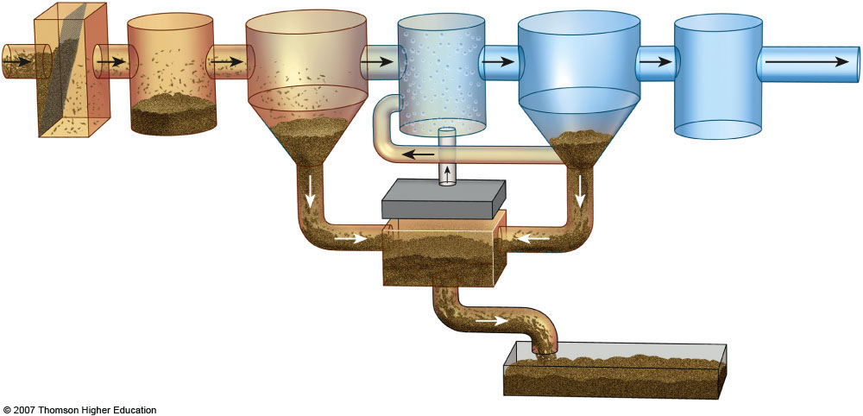

- In the box to the right, list the ranks of coal in order from highest to lowest energy content. (indicate the direction in the box.)
- List three air pollutants that are emitted during the burning of coal.
1) 2) 3)
- List 7 products that are derived primarily from crude oil:

- The acronym OPEC refers to the _____________ of _____________ _____________ _____________ and it is important because:

- Fracking is short for ______________ ______________ and it is a concern because…

- Explain what the Deepwater Horizon was, where it went, and why it is significant.

- The acronym ANWR refers to the _____________ _____________ _____________ _____________ and it is important because:

- Perform the following calculations: (Show all of your work in a logical progression to the final answer.)
  - A family has a total of 1500 Watts of light bulbs throughout their house, if they replace them all with LED light bulbs, which use 90% less energy, the family will now use _____________ Watts of electricity.
Show work:

  - A space heater operates at 1500 Watts, if it is used for 10 hours each day for one week and the cost of electricity is 20 cents per kilowatt-hour, it will cost _____________ to operate the heater for the week.
Show work:

- The acronym CAFE refers to the _____________ _____________ _____________ _____________ and it is important because:

- List four things you could do to conserve energy.
1)
2)
3)
4)
- State where Chernobyl is located and explain what happened there.

- Complete the following chart.
Mining Technique | Description | Environmental consequences
Open-Pit mining
Subsurface mining
Strip mining
Mountaintop removal
Drilling
- Strengthen this weak statement: “Mining causes pollution that may disrupt the environment.”

- Match each of the following elements with its ore:
  - aluminum galena
  - iron quartz
  - uranium bauxite
  - lead hematite
  - silicon pitchblende
- Explain what happened at Three Mile Island, and why it is significant.

- Explain how thermal pollution is produced by power plants.

- Explain what happened at Fukushima Daiichi and why it is significant.

- Perform the following calculation. Show all of your work. A radioactive cloud may contain Iodine-131, which has a half-life of 8 days. If the waste must decay to a concentration of less than 0.1% to be considered safe, it will take approximately ______ days to reach safe levels.
Show work:

- List three species that may be threatened by the construction of a solar power tower in the California Desert.
1)
2)
3)
- _______________ is the active element in most photovoltaic cells.
- Perform the following calculation. (Show all of your work in a logical progression to the final answer.) A family has a 75 m² solar array on their house, which has an efficiency of 10%. If the average insolation on their array is 6 kWh/m²/day and their average cost of electricity is 20 cents per kilowatt-hour, the family has the capacity to produce _________ worth of electricity every day, and _________ every year, from the sun.
Show work:

APES Review Worksheet #5
- Name the following:
NO NO₂
NO₂⁻ NO₃⁻
NO₂ N₂O
N₂ NH₃
NH₄⁺ HNO₃
NO_{x}
- In the box to the right, sketch a house and the surroundings of a house that is designed to make the greatest use of passive solar energy in the northern hemisphere. Include, inside the box, the location of both the winter and summer sun, and labels to indicate the compass direction that the house faces.
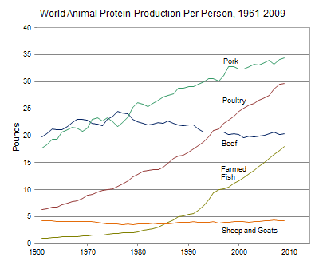
- Use the information in the diagram on the left, to answer the following:
  - The percent change in the per capita global production of protein from poultry between 1980 and 2000 was approximately ________.
  - The percent change in the per capita global production of protein from farmed fish between 1980 and 2000 was approximately ________.
  - The percent change in the per capita global production of protein from beef between 1961 and 2009 was approximately ________.
- The founder of the Sierra Club was ________ ________.
- Rachel Carson wrote the book ________ Spring to raise people’s awareness of the harmful effects of the pesticide ________.
- The acronym ENSO refers to _____________ _____________ _____________ _____________, which occurs in the _____________ ocean.
- Place the following 8 events in chronological order: the oil spill of the Exxon Valdez; the meltdown of the reactor at Chernobyl; the discovery of contamination at Love Canal; The first Earth Day; the leak of methyl isocyanate in Bhopal; the drafting of the Kyoto Protocol; the ratification of the Montreal Protocol, passage of the US Endangered Species Act
1) 5)
2) 6)
3) 7)
4) 8)
- Strengthen this weak statement: “Fossil fuel use releases carbon dioxide, which causes the greenhouse effect.”

- The acronym BOD refers to _____________ _____________ _____________, which is:

- Perform the following calculation. Show all of your work. If the grasses on a 100-hectare area of grassland grow at an average rate of 1 cm/day, the average volume of grass that is added to the grassland each day is ____________ m³. If the density of the grasses that grow in the grassland averages 400 kg/m³, the net primary productivity is approximately _____________ g/m²/day or _____________ g/m²/year.
Show work:

- The acronym GMO refers to _____________ _____________ _____________, which are:

- Strengthen this weak statement: “Protecting endangered species like the Giant Panda costs too much and should be stopped.”

- Perform the following calculation. Show all of your work. A 40 m² solar array is installed on a house where the average insolation is 6 kWh/m²/day if the average total electricity output of the array is 1.2 kWh/hr, the efficiency of the array is ____________.
Show work:

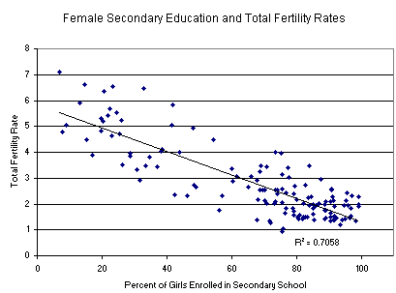
- Consider the graph on the right and explain what can be inferred from the data it presents.

- The first National Park was ________________ National Park.
- Match the ten most populous urban areas in the world with its respective continent:
Tokyo
Seoul
  - Asia Mexico City
  - N. America New York City
  - S. America Mumbai
  - Africa Jakarta
  - Australia Sao Paulo
  - Europe Delhi
Osaka/Kobe
Shanghai
- List three sources of methane that are amplified by human activities.
1)
2)
3)
- The box to the right contains a crude depiction of a mountain, use it to sketch and label the essential atributes of a rain shadow. Include labels for the direction of the prevailing winds and nearest ocean.
- NO₂ is converted to N₂ and O₂ in a _____________ _____________, which also converts _____ to _____.
- List causes of an urban heat island.
1)
2)
3)
- Identify the characteristic process associated with each of the following.
Nitrification:
Denitrification:
Assimilation:
Nitrogen Fixation:
Ammonification:
- CFC stands for _______________________________________,which are:

- Define the following…
Watershed:
Clean Air Act:
Clean Water Act:
Clean Drinking Water Act:
El Niño:
Baghouse filter
Electrostatic precipitator:
Dioxin:

